COMPANY PROFILE

Infostretch Solutions Private Limited



About

Infostretch is a leading provider of mobile and enterprise QA services and solutions. Our offerings range from enterprise QA, mobile application development, testing, and automation to certification and sustenance. We've been providing expert solutions and services to various large and strategic players in the mobile ecosystem including enterprises, carriers, app stores, VAS, and ISV's to actualize their mobile and QA strategy very successfully.

We offer the most cost effective, secure, and scalable models to service our clients across various verticals such as banking, healthcare, education, and entertainment to name a few. Our innovations have allowed us to provide an SLA of 24hours and the ability to scale and test over 2,000 apps a day.

Infostretch was formed in 2004 by a team of highly qualified and experienced professionals known in the software QA world. The team came together with the goal of leveraging their international industry experience to build a global, comprehensive services organization with the highest quality of services.

Vision

Providing cost effective QA and Test Automation services to global customer base and have managed to grow significantly since its inception and create a distinct brand for its services.

Provide value-added solutions that significantly improve the quality of software by leveraging technology

Mission

Serve customer needs globally by innovating market-leading information technology products and solutions to deliver the highest quality in software while leveraging business best practices and integrated world-class talent.

STRETCH the reach of technology to deliver superior solutions, STRETCH the boundaries of geographies to deliver cost-effective solutions, STRETCH our customer’s efforts with expertise and sincerity to deliver meaningful Information to customers so they can make Informed decisions. Doing more with less while stretching as much as possible.
Values:

Customer Satisfaction

We put forth the extra effort to ensure our customers success – even under the most challenging conditions. Customer Satisfaction is our top priority in all of our engagements and we track employee performance metrics that are centered on delivering customer satisfaction.

Commitment to Employees

We nurture teamwork, candidness and wisdom among our employees to get the best out of each one of them. Management is devoted and committed to growth, satisfaction and performance. We strongly believe that happy employees produce happy customers.

Passion for What We Do

We are passionate about what we do. We make sure every employee is happy with their work and feels pride in accomplishing the task at hand. We set high standards for everyone in the company and ensure that we attain them.

Thinking Outside the Box

Technology, Processes, Decisions: Our innovative thinking is rooted in all aspects of our existence. We strive to foster innovation, top down and bottom up throughout the organization.

Increasing Value for our Share Holders

While keeping Customer satisfaction and employee commitment as top priorities, we put genuine effort into creating valuable relationships, offering reusable IP and marketing brand strategy, resulting in greater value for our shareholders.

Quality Strategy Process

Discover – Define – Demonstrate – Realize

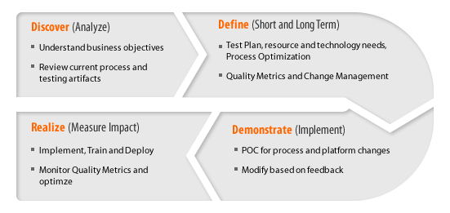

Some of the many accolades earned by Infostretch include:

2008 | - Gartner Top 20 QA Service Provider Exceptional QA Services and Solutions for Enterprise, Mobile and SaaS.
2009 | - Business Journal: Awarded "Fastest 30 Privately Owned Companies in Bay Area".
2010 | - Business Journal: Awarded "Fastest 30 Privately Owned Companies in Bay Area".  - Lead411: Ranked among " TOP 200 Fastest Growing Companies” in USA in 2010.  - GESIA: Rising Star in Best Software Product & Service Company.  - Awarded Inc 500/5000 Company of the Year 2010.  - Best of Santa Clara Award for Mobile & Software Testing.
2011 | - GESIA: Silver Award for best service company.  - The company is among the 20 fastest growing technology companies in Silicon Valley, California.  - Forbes: Among Top Most Promising Companies in US.
2012 | - GSIA: Platinum Award for Best Mobile Application Development Company.  - NASSCOM Applauds Infostretch's Growth.
2013 | - Named an Ernst & Young Entrepreneur of the Year® 2013 Semifinalist Northern California.  - Named a Fast 50 Asian American Business for 2013.  - Ranked 44th in the Prestigious Tech 200 List

